FOR IMMEDIATE RELEASE

NEW AND UNIQUE LIVE-ACTION MYSTERY-ADVENTURE THE CENTENNIAL CASE: A SHIJIMA STORY NOW AVAILABLE

Players Will Take on the Immersive Mystery Story, Reveal the Culprit and Uncover the Truth behind the Case!

LONDON (MAY 12, 2022) – SQUARE ENIX® and video game developer h.a.n.d., Inc. announced today that The Centennial Case: A Shijima Story, an immersive live-action mystery-adventure game is now available on the PlayStation®5 (PS5™) console, PlayStation®4 (PS4™) console, Nintendo Switch™ system and PC (STEAM®).

Watch the launch trailer for The Centennial Case: A Shijima Story here:
https://youtu.be/zCPjUC-_O-Q

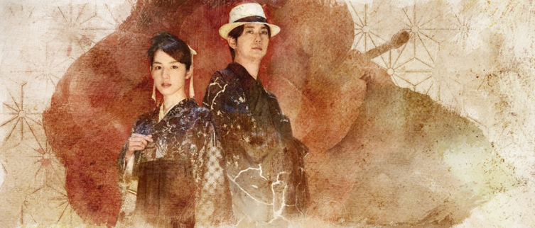

Directed by Koichiro Ito (Metal Gear Solid V) and produced by Junichi Ehara (NieR:Automata, BABYLON’S FALL), The Centennial Case: A Shijima Story centers around the ill-fated Shijima family, who have experienced a chain of inexplicable deaths in their family over the past century. Yasuhito Tachibana, producer of Netflix’s The Naked Director, serves as Cinematographer and Scenario Director, taking visual storytelling to a new level with high-quality cinematography and thrilling live-action.

Players will take on the role of mystery writer, Haruka Kagami and use their powers of deductions to uncover the truth behind four murder cases that have taken place in the Shijima household over the last one hundred years. Immerse into an authentically traditional Japanese story, transcend time across different eras of Japan and collect information scattered throughout each era to uncover the truth and solve an age-old mystery.

The Centennial Case: A Shijima Story features compelling performances from Nanami Sakuraba as the games’ protagonist, Haruka Kagami and Yuta Hiraoka as Eiji Shijima, the second son of the Shijima family who returns home to help unravel the mystery behind his ill-fated family. A cast of talented Japanese actors bring this enigmatic Japanese adventure to life, depicting an array of characters throughout each period setting.

(Nanami Sakuraba, Yuta Hiraoka)

“The Centennial Case: A Shijima Story is a game that takes the form of a live-action drama surrounding the murders within the Shijima family that have taken place over a century, which the player will help the characters to solve.The in-game videos have been filmed in live action, so please keep an eye out for the subtle expressions, gestures and movements that can’t be captured in games that use CG graphics! I hope you’ll enjoy unravelling the mysteries behind the incident together with Haruka!” Said Nanami Sakuraba who plays the role of Haruka Kagami.

“My first impression of this story that spans different time periods was to think, “Is this even possible?” and, “This script is really something!” The sheer volume of lines and the tight filming schedule were dizzying, but I think the choice to intentionally film sections that could quite plausibly have been created with CG in an analogue style lends a wonderful retro feel to the game and gives a greater sense of realism to the performance. I’d love for players to fully experience this story about the mysteries of the Shijima family, the murders, and love, that transcends time and space.” added Yuta Hiraoka who lends his talents as Eiji Shijima.

Those who purchase the game before May 19, 2022, will receive the base game, The Centennial Case: A Shijima Story BEHIND THE SCENES, comprising of 50 minutes interview footage and The Centennial Case: A Shijima Story mini soundtrack composed by Yuki Hayashi, Daiki Okuno, Ryoshi Takagi, Shuichiro Fukuhiro and Shogo Yamashiro.

For more information, visit: https://square-enix-games.com/en_GB/games/centennial-case-shijima-story

Related Links:
Official Website: https://square-enix-games.com/en_GB/games/centennial-case-shijima-story
STEAM Store: https://store.steampowered.com/app/1612780/
Nintendo Switch: https://www.nintendo.com/store/products/the-centennial-case-a-shijima-story-switch
Twitter: https://twitter.com/SquareEnix
Facebook: https://www.facebook.com/SquareEnix
YouTube: https://www.youtube.com/c/squareenixna
Instagram: https://www.instagram.com/squareenix

About Square Enix, Ltd.
Square Enix Ltd. develops, publishes, distributes and licenses SQUARE ENIX®, EIDOS® and TAITO® branded entertainment content in Europe and other PAL territories as part of the Square Enix group of companies. Square Enix Ltd. also has a global network of leading development studios such as Crystal Dynamics® and Eidos Montréal®. The Square Enix group of companies boasts a valuable portfolio of intellectual property including: FINAL FANTASY, which has sold over 168 million units worldwide; DRAGON QUEST®, which has sold over 84 million units worldwide; TOMB RAIDER®, which has sold over 88 million units worldwide; and the legendary SPACE INVADERS®. Square Enix Ltd. is a London-based, wholly owned subsidiary of Square Enix Holdings Co., Ltd.

More information on Square Enix, Inc. can be found at https://square-enix-games.com

# # #

© 2022 SQUARE ENIX CO., LTD. All Rights Reserved.
Developed by h.a.n.d., Inc. Story by Nemeton.

THE CENTENNIAL CASE: A SHIJIMA STORY, CRYSTAL DYNAMICS, DRAGON QUEST, EIDOS, EIDOS MONTREAL, FINAL FANTASY, SPACE INVADERS, SQUARE ENIX, the SQUARE ENIX logo, TAITO and TOMB RAIDER are registered trademarks or trademarks of the Square Enix group of companies. All other trademarks are properties of their respective owners. "PlayStation,” “PS5,” and “PS4” are registered trademarks or trademarks of Sony Interactive Entertainment Inc. Nintendo Switch is a trademark of Nintendo Co., Ltd. Steam and the Steam logo are trademarks and/or registered trademarks of Valve Corporation in the US and/or other countries. All other trademarks are the property of their respective owners.

