FOR IMMEDIATE RELEASE

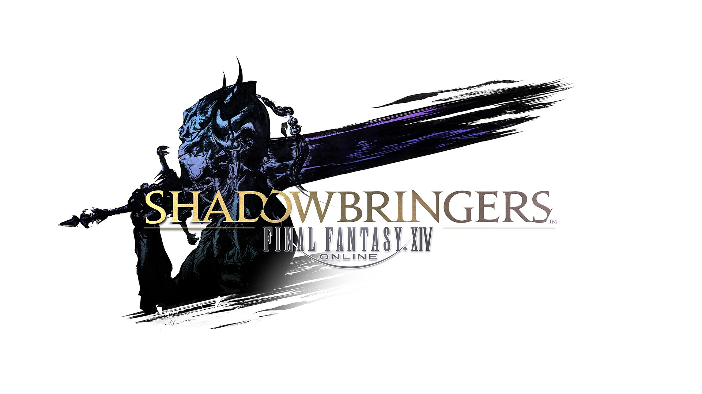
FINAL FANTASY XIV ONLINE STORMS INTO PLAYSTATION®5 OPEN BETA TODAY AS PATCH 5.5 USHERS IN THE END OF DAYS

PS5™ Release Brings Framerate Improvements, Faster Load Times, 4K Resolution Support, DualSense Haptic Feedback, New Trophies, and 3D Audio Support

LONDON (13th April, 2021) – SQUARE ENIX® is setting the stage for the next major adventure in FINAL FANTASY® XIV Online with today’s release of Patch 5.5. The update, titled Death Unto Dawn, brings with it climactic new story content set to lead directly into upcoming fourth expansion Endwalker™, alongside the highly-anticipated third chapter of YoRHa: Dark Apocalypse—the NieR-inspired alliance raid featuring the work of guest creators Yosuke Saito and YOKO TARO. The patch also brings an abundance of battle content, system updates, and more.

The Patch 5.5 trailer is available to view here: https://www.youtube.com/watch?v=VG9VC5B_wRw

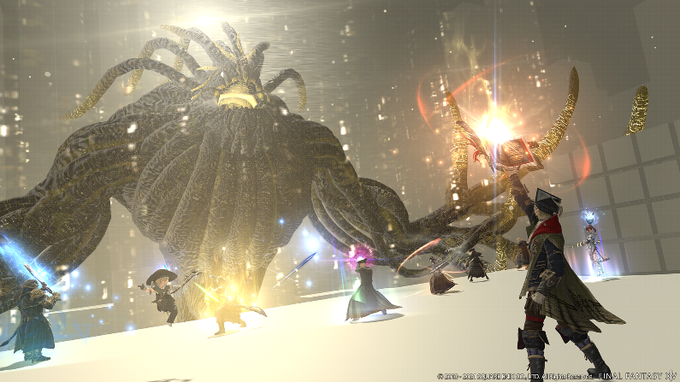
The Third Chapter of YoRHa: Dark Apocalypse Arrives Today

Today also marks the start of open beta for the PlayStation®5 console version of FINAL FANTASY XIV Online. Players can look forward to a range of new features and additions, including framerate improvements, faster load times, 4K resolution support, DualSense haptic feedback, new trophies, and 3D audio support.

Users with a PlayStation 4 license registered to their account can upgrade to the PS5 Upgrade Edition at no extra cost at the start of the open beta period, while new players can experience the game on the PlayStation 5 via the Free Trial version. The full PlayStation 5 version will be available for purchase following the conclusion of the open beta.

A trailer for the PlayStation 5 version of the game can be seen here: https://www.youtube.com/watch?v=L7ZEkdtTp8o

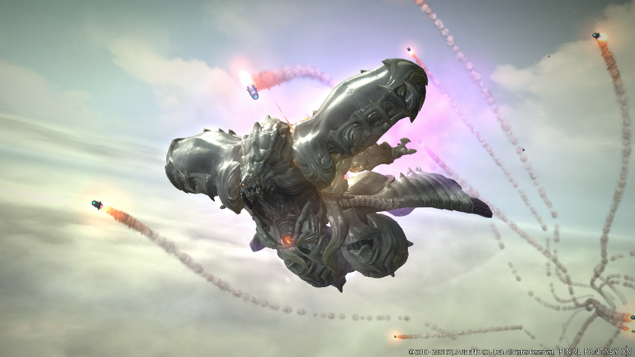
Diamond Weapon is the Latest Challenging Trial in the Sorrow of Werlyt Questline

Further details on Patch 5.5 content are outlined below:

- New Main Scenario Quests – Prospects of peace may soon fall to ruin, as Fandaniel and the Telophoroi scheme to recreate the Final Days, and ominous towers rise in all corners of the realm. With the servants of chaos amassing at every turn, will the Scions uncover their plot before it is too late?
- New Alliance Raid: The Tower at Paradigm's Breach – The white-garbed 2P's discovery was the first domino to fall in a series of conflicts that have only escalated since the arrival of the black-shrouded 2B, the pattern they form growing ever more complex. The time of revelation may be at hand, but is this tale one of hope...or despair?
- “Sorrow of Werlyt” Questline Finale – With adamantine armor and a beating, blood red core, the Diamond Weapon is the culmination of countless sacrifices and untold suffering. When the ultimate triumph of the VIIth Legion's monstrous Weapon project descends upon Werlyt, who will be saved, and who shall fall?
- New Trial: The Cloud Deck – The advent of the Empire's final and most fatal Weapon sees Gaius and the Warrior of Light take to the skies aboard Cid's latest creation. Players can face off against the fearsome Diamond Weapon in this latest trial, which will be available in both Normal and Extreme difficulties.
- New Dungeon: Paglth'an – Players can tackle this new story dungeon alongside fellow adventurers or a party of non-player characters via Trust System compatibility.
- “Save the Queen” Questline Update – This latest update includes a new field area, “Zadnor,” an increased resistance rank cap, final enhancement of resistance weapons and more.
- New Unreal Trial – The next powered-up primal, Leviathan, has returned from A Realm Reborn to terrorize level 80 heroes, providing them with a hefty challenge and chances at unique rewards.
- Crafter Updates – High-level crafters can look forward to new content in Patch 5.5 that will earn them special achievements and unique crafting tools.
- Ishgard Restoration Update – As a new age dawns in Ishgard, luminaries from across Eorzea have been invited to the Firmament to take part in a ceremony commemorating this momentous occasion. Players can obtain rewards by participating in gatherer- and crafter-focused events which will occur during these periodic celebrations.
- “Explorer Mode'' Update – The Explorer Mode feature will be expanded to include level 70 dungeons. Explorer Mode allows players to explore dungeons free from danger to capture striking and fun screenshots while enabling the use of mounts and minions. Players will also now be able to use performance actions while in dungeons, such as playing musical instruments.
- New Game+ Updates - Relive even more past adventures in Patch 5.5 with the addition of Eden, the Sorrow of Werlyt, and other Tales from the Shadows. Main scenario quests from Patch 5.4 to Patch 5.55 and YoRHa: Dark Apocalypse are also coming to New Game+ in Patch 5.55.
- New Custom Deliveries - House Durendaire is considered the foremost of the noble houses of Ishgard, and Count Charlemend stands at its head. Thus, when such a dignitary is seen skulking about the Firmament, it could scarcely go unnoticed. What manner of surreptitious business could have brought the man to the newly rebuilt district?
- Performance Action Updates – A new instrument will be added with Patch 5.55.
- Job Adjustments for PvE and PvP Actions, New Mounts, Minions and more.

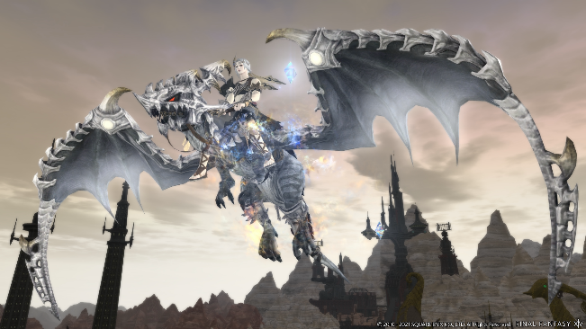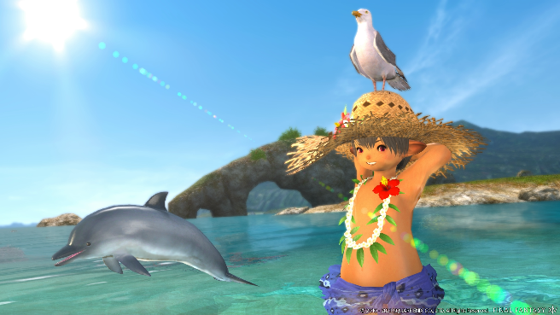
Obtain New Mounts and Minions in Patch 5.5

Further details about the upcoming Digital Fan Festival on 15th – 16th May were also revealed. On 15th May, fans can expect an exciting keynote filled with new information on Endwalker, a developer panel, and a piano concert. 16th May’s events will also provide enjoyable content for fans, with a Letter from the Producer LIVE and a concert from THE PRIMALS. For more information on the Digital Fan Festival 2021, visit the official website here: https://fanfest.finalfantasyxiv.com/2021/eu/

The recently announced fourth expansion pack of the FINAL FANTASY XIV Online saga, Endwalker, is scheduled to release fall 2021 for PC, Mac, the PlayStation®5 system, and the PlayStation®4 system. Endwalker is the culmination of the Hydaelyn and Zodiark story, in which Warriors of Light will encounter an even greater calamity than ever before, and will bring an abundance of new content, including multiple new jobs, an increased level cap, vast new areas, adjustments to the battle system, as well as a variety of new battle, crafter, and gatherer content.

FINAL FANTASY XIV: Endwalker’s teaser trailer can be found here: https://www.youtube.com/watch?v=HsVraq-v0JI
Visit the official FINAL FANTASY XIV: Endwalker site here: http://eu.finalfantasyxiv.com/endwalker/
With over 22 million total registered players and a new expansion on the way, there has never been a better time for newcomers to begin their adventures in the critically acclaimed FINAL FANTASY XIV Online saga. The recently expanded Free Trial now includes all content from A Realm Reborn and the Heavensward™ expansion (and updates through Patch 3.56), as well as an additional playable race (Au Ra), and three additional playable jobs (Dark Knight, Astrologian, and Machinist). Free Trial players can enjoy hundreds of hours of award-winning gameplay and story experiences equivalent to two full FINAL FANTASY titles, without limit on playtime.

Related Links
Endwalker Teaser Site: http://eu.finalfantasyxiv.com/endwalker/
SQUARE ENIX® Press Site: https://www.square-enix-press.com/
The Lodestone®: http://eu.finalfantasyxiv.com
Official Facebook®: https://www.facebook.com/FinalFantasyXIV
Official Twitter®: @FF_XIV_EN
Official Instagram®: @ffxiv
#FFXIV

About Square Enix Ltd.
Square Enix Ltd. develops, publishes, distributes and licenses SQUARE ENIX®, EIDOS® and TAITO® branded entertainment content in Europe and other PAL territories as part of the Square Enix group of companies. Square Enix Ltd. also has a global network of leading development studios such as Crystal Dynamics® and Eidos Montréal. The Square Enix group of companies boasts a valuable portfolio of intellectual property including: FINAL FANTASY®, which has sold over 161 million units worldwide; DRAGON QUEST®, which has sold over 82 million units worldwide; TOMB RAIDER®, which has sold over 82 million units worldwide; and the legendary SPACE INVADERS®. Square Enix Ltd. is a London-based, wholly-owned subsidiary of Square Enix Holdings Co., Ltd.

FINAL FANTASY XIV © 2010 - 2021 SQUARE ENIX CO., LTD. All Rights Reserved.
FINAL FANTASY XIV: ENDWALKER © 2021 SQUARE ENIX CO., LTD. All Rights Reserved.
LOGO ILLUSTRATION: ©2021 YOSHITAKA AMANO
ENDWALKER, SHADOWBRINGERS, the FINAL FANTASY XIV logo, CRYSTAL DYNAMICS, DRAGON QUEST, EIDOS, EIDOS MONTREAL, EORZEA, FINAL FANTASY, the FINAL FANTASY logo, THE LODESTONE, SPACE INVADERS, SQUARE ENIX, the SQUARE ENIX logo, TAITO and TOMB RAIDER are registered trademarks or trademarks of the Square Enix group of companies. PlayStation" and the "PS" Family logo are registered trademarks and "PS4" and “PS5” are trademarks of Sony Interactive Entertainment Inc. All other trademarks are properties of their respective owners.

###
Contact (press only):
Luke Karmali
Square Enix, Ltd.
+44 (0) 7813 374414
LukeK@eu.square-enix.com

